HOTEL ACCOMMODATIONS

The 19th Annual NHPRS Conference – Montreal hotels are all within walking distance to the venue held at Université du Québec à Montréal (UQAM)
HOTEL RESERVATIONS
There are only a limited numbers of hotel rooms available. To ensure availability, please be sure to make your hotel reservations as soon as possible.

How to book your reservation:
To make a hotel reservation, please kindly verify the below list of hotels available and contact the hotels directly via the individual web links provided. If you are calling, please make sure to mention that you are attending the The 19th Annual NHPRS Conference to receive the preferred hotel rate.

Please note all room rates are in Canadian dollars and exclude taxes!

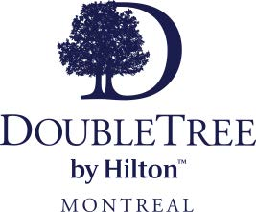

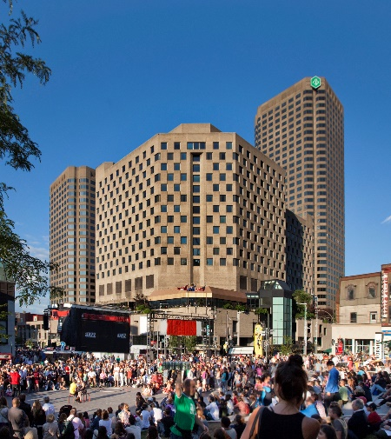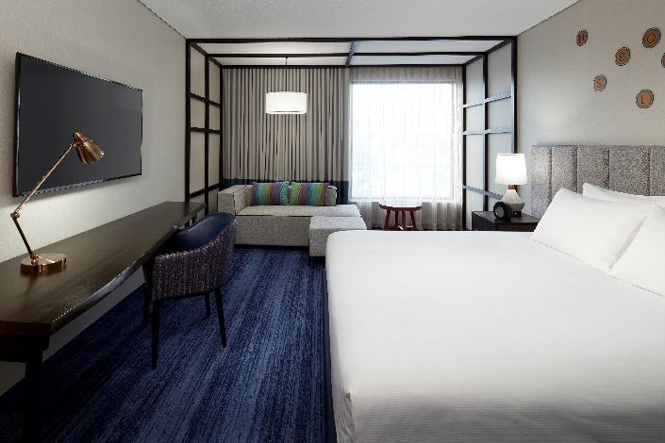

MAIN CONGRESS HOTEL

DoubleTree par Hilton Montréal
Room Rate: $289.00 Standard Single/Double

Address: 1255 Jeanne-Mance St, Montréal, QC H5B 1E5

Tel: +1 (514) 285-1450
Walking Distance to UQAM: 7 minutes

To reserve your room: WEBLINK

Website: doubletreemontreal.com

About: DoubleTree by Hilton Montreal is the largest property connected to Palais des congrès, Complexe Desjardins and Place des Arts. Close to Old Montreal, Sainte-Catherine Street's shopping, the local food scene and steps away from Place des Festivals, DoubleTree Montreal is the hotel to live a true Montreal Experience

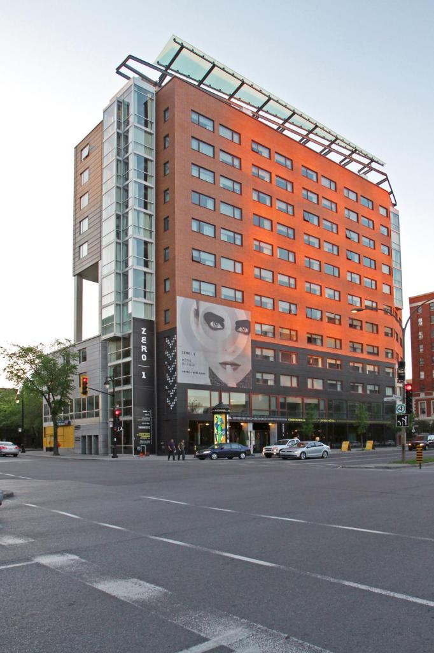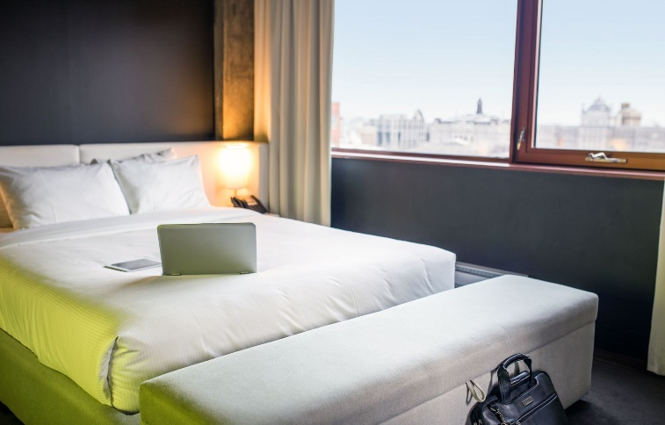

Hotel ZERO 1

Room Rate: $209.00 Standard Single/Double

Address: 1 Boulevard René-Lévesque E, Montréal, QC H2X 3Z5

Tel: +1(514) 871-9696

Walking Distance to UQAM: 13 minutes

To reserve your room: http://bookings.ihotelier.com/bookings.jsp?groupID=3826076&hotelID=77400

Website: https://www.zero1-mtl.com/

About: Named after its address (01 Boulevard René-Lévesque East), Hotel ZERO1 originally functioned as a student residence from 2000 to 2009 for Cegep du Vieux-Montreal and UQAM students. In 2009 the property was purchased by Groupe Cholette, which shuttered the building for 12 months of intense renovations. Hotel ZERO1 opened its rooms to guests in 2010 and has since been celebrated as one of Montreal’s most stylish & modern boutique properties.

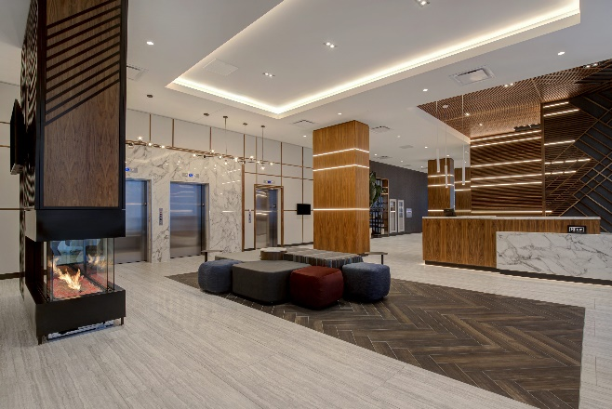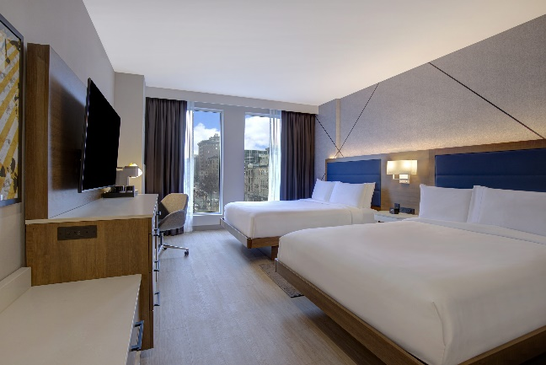

Hampton Inn by Hilton Montreal Downtown
Room Rate: $239.00 Standard Single/Double / includes breakfast and Wi-Fi

Address: 985 Boul. St-Laurent, Montreal, Quebec, H2Z 1J4, Canada

Tel: +1 (514) 370-7777

Walking Distance to UQAM: 17 minutes

To reserve your room:
Link

Website: https://www.hilton.com/en/hotels/yulmohx-hampton-montreal-downtown/
About: Our hotel is just half a kilometer from the Montreal Convention Center in the heart of downtown. We are surrounded by restaurants, government offices, museums, theaters, and historic attractions. Subway and bus stations are within three blocks, and we are just off A-720. Our rooftop terrace and expansive meeting spaces are ideal for Montreal events.

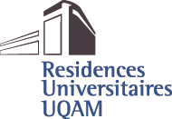

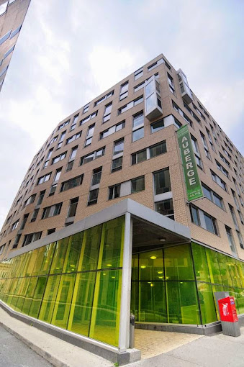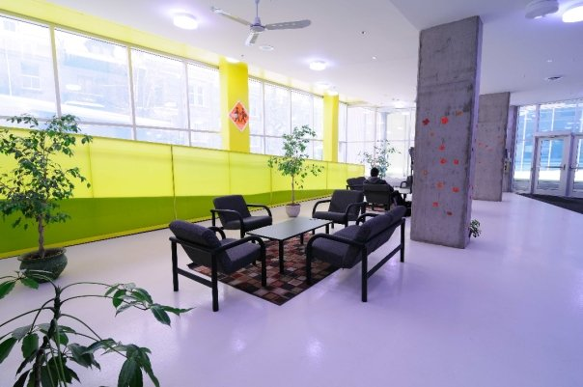

RÉSIDENCES UNIVERSITAIRES SAINT-URBAIN UQAM

Room Rate: $103.00 Subject to change / summer prices not yet available

Address: 2100 St Urbain St, Montréal, QC H2X 3X8

Tel: (514) 987-7747

Walking Distance to UQAM: 2 minutes

To reserve your room: please note rooms are not yet available, link will be provided when it becomes available.
Website: https://services.uqam.ca/services-offerts/residences-universitaires/

Conference will be held at :

Pavillon SH - Plan du campus | UQAM

www.coeurdessciences.uqam.ca

For all other Hotel Inquiries please contact LINSA Inc.
Email: lsalvati@linsa.ca Number: 1-450-458-1696

Beware of Unauthorized Hotel Solicitations & Fraudulent Housing Claims
Please note that LINSA Inc. is the only official housing company associated with 19th Annual NHPRS Conference. While other hotel resellers may contact you offering housing for your trip, they are not endorsed by or affiliated with the congress. Beware that entering into financial agreements with non-endorsed companies; including Convention Housing Services, Exhibitors/Exhibition Housing Services, Global Expo Housing, Global Housing Corp., etc. can have costly consequences.
If you have any doubts or concerns, please contact Lina Salvati from LINSA at 514.924.3476. lsalvati@linsa.ca
19th Annual NHPRS Conference, The Natural Health Product Research society of Canada, & LINSA Inc. will not sell or rent your email address.

